“When I stand before God at the end of my life, I would hope that I would not have a single bit of talent left, and could say, 'I used everything you gave me.”
― Erma Bombeck

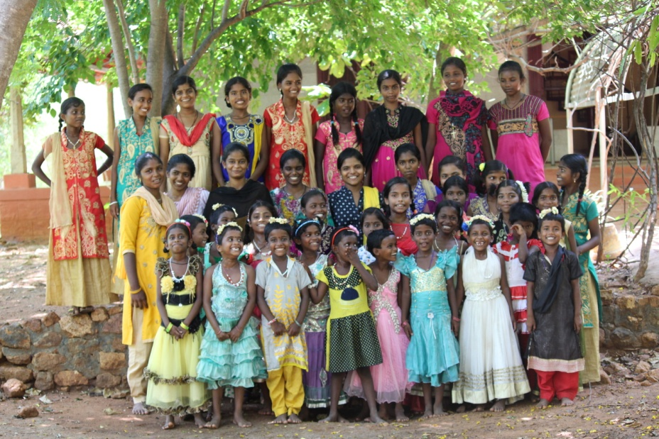

Introduction:
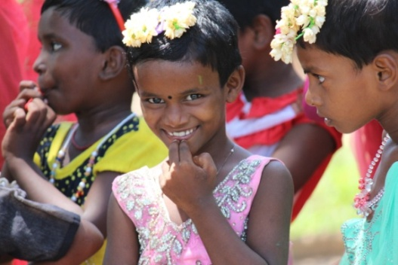
Everyone in the world is filled with bundle of talents. It is due that the parents are to provide ample opportunities for them to explore those talents, gifts in this universe before while we live on this earth. St. Joseph’s Development Trust (SJDT) accommodates children who cannot such chances when they are with their parents. SJDT always eyes at the development of children and equip them with multi talents. This year has been very special as SJDT arranged different programs for the children during this summer. Children’s talents were identified and they were chosen for different events. Let’s have quick look at the programs carried out in the institute during this summer holidays.
Joy of being loved

Music Class:
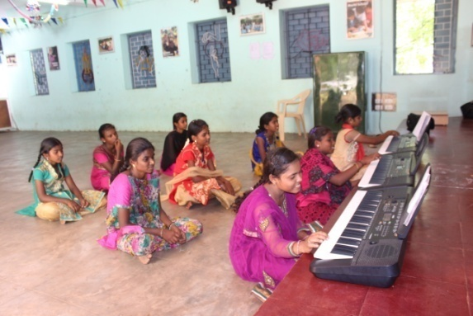
Music is one of the best ways to sooth the soul that is troubled. Seldom there can be people who are not interested in music. Our girls are always fond of music and dance and you know it well indeed. Though our girls listen to music a lot, playing an instrument is a new task given to them this year. A music teacher is arranged to teach key board to the senior girls who are interested in music. The classes were interesting and the girls started picking it up very easily. They grow in confidence and music and now almost all of them can play for a song at least. Some of them play songs for entire Eucharistic celebration even. We could witness the drastic improvement in the children and their music skill.
Learning a new skill
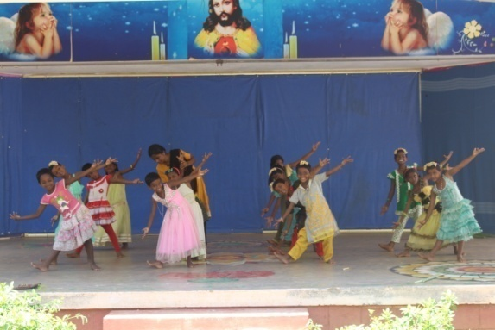
Growing in dancing:
We can proudly say that our girls are excellent in dancing. It has wonderful to watch their performance. To continue same kind of standards and perfection it is very important to train the young kids. So the younger children are given orientation to different kind of dances such as Bharatham, Parai, Oyilaattam and etc. Our Executive Director wants to see the improvement the kids have arrived at and the children also got a chance to exhibit their learning during the birthday celebration of Ms. Devi Bala. The visitors were profoundly mesmerized by the performance of those kids. We are very sure to see them dancing in big stages soon and bring name and fame to the institute.
Shaping kids in dancing

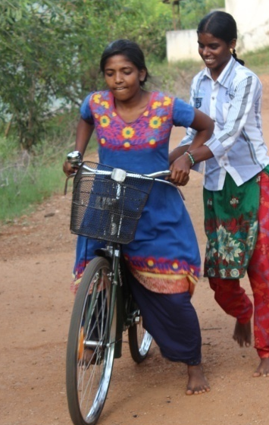
Learning Cycling:
This summer holidays were time for younger children to learn new skills and talents actually. The girls who did not know cycling were taught and helped to learn cycling by the senior girls or who know cycling. It was fun to certain extent but at the same time it is a learning process. Girls have to learn this basic and important skill. They were so happy in the end that they could learn a new skill during this summer holidays. They felt that these days were used fruitfully to shape them well.
Helping a friend to learn cycling
Gardening:
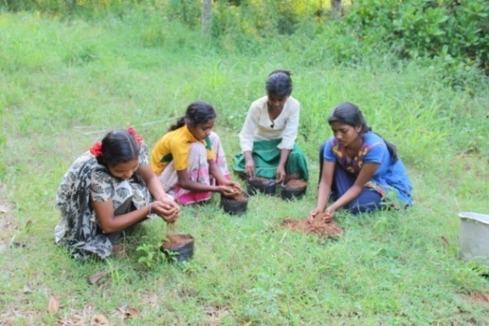
In the earlier years the children were given training to make vermicompost manure which eventually can be utilized in farming and agriculture. This time the children were given training to make saplings and that can be planted during rainy season of this year. This event is organized to keep the children occupied in a useful way. The children have to know the pain and difficulties of farmers. Though society gets all comforts it is farmers who make us live. It is fitting that everyone learns something about farming. It also creates a kind of respect for farmers and helps the students to value the importance of agriculture.
Time to get some saplings to nurture the nature
Birthday Celebration:
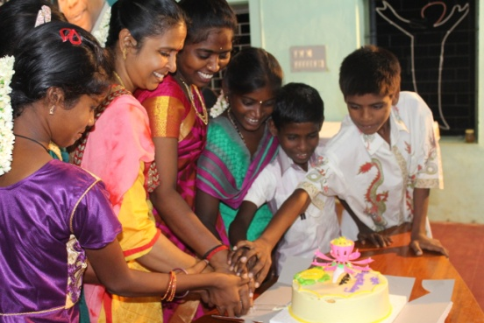
It is time to have some fun and enjoyment during this summer holidays. We had celebrated the birthday of Ms. Devi Bala on 17.05.2018 though it was belated celebration. This event paved a chance for the children to exhibit their talents and learning. The children who learned dancing and music could express their talents on this day. The celebrated was started with Eucharistic celebration. During this celebration the upcoming musician could expose their skill of playing the keyboard for devotional hymns. It was indeed excellent work by the girls and they made the celebration more meaningful both with their melody voices and excellent music. It was followed by cutting the cake and the participants wishing the celebrant happy birthday. Then the extravaganza of dance began to entertain the participants. This time it was with young kids and they performed wonderfully well. It was blissful to watch actually. They did it so well that everyone was pleased a lot. It was worth training them and we are sure they are emerging dancers.

Come on, let's celebrate
Picnic to Velankanni Shrine:
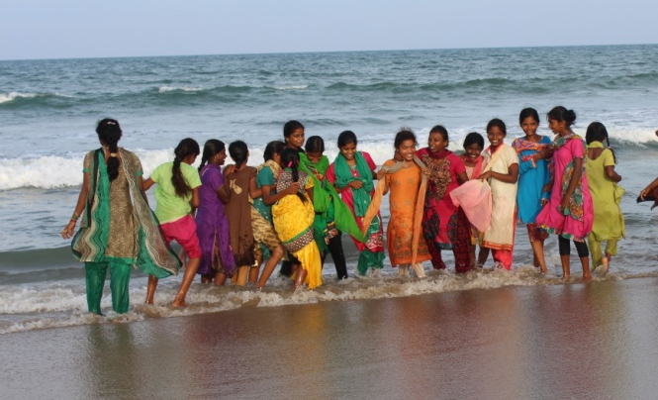
This year also the children were taken to Velankanni shrine on 23.05.2018. The children were very happy to be there once again. Everyone had sincere prayer in different churches and shrines. On finishing our prayers and worship everyone visited the beach where children had fun and memorable time. They bathed and played in sea and had good time. The holiday special programs was ended in good note with this picnic and definitely they will be looking forward to next year’s annual exam holidays.
Fun with friends in the beach
Conclusion:
We are happy to present you this report to you as you are important to these children in their lives. It is you support them to ensure great future for them. We are so pleased that we could carry out the dream you have for them. Your continuous support is essential in making them realize their dream and future. We strongly believe and hope to render the same kind of qualitative service to the deserted and poor children with your benevolent support.

